SportyShoes

SPECIFICATION DOCUMENT

JAVIER LUQUE

POST GRADE FULL STACK DEVELOPMENT
BACK-END EXPERT
COHORT 1
2022
Table of Contents
Problem Background 3
Developer Details 3
Project Details 3
jluqueco/LockedMe 4
Sprints 4
Algorithms 4
Application Flow 5
Core Concepts 6
GitHub Tracking 6
Conclusion 7

Problem Background
● Manage the products in the store including categorizing them
● Browse the list of users who have signed up and be able to search users

Developer Details
Javier Luque will be the developer of this SportyShoes project; he is currently a junior Java developer with little experience but eager to learn and to show what he has learned up to this point.

He will be also the project manager and will be in charge of the planning, monitoring and execution of this demo.

Project Details
This project will be divided into two springs (details on the sprint execution document). Estimation were based in hours per day. Third week is planned for changes requested by the user after the demo has been displayed.
All the documentation for this project could be found in the following Github repo:

jluqueco/SportyShoes

This project was built using REST micro-services (resources package). These micro-services are consumed by a controller that coordinates all the user requests through the different views and link them to their respective service. JPA was used to manage all the repositories. Here is an overview of the architecture of the solution:
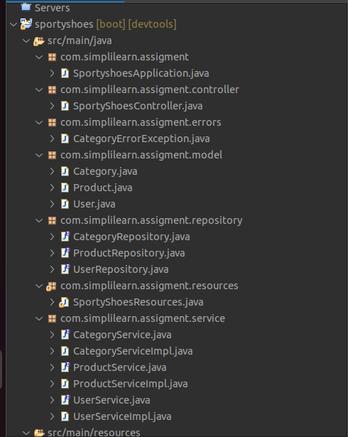

Sprints
As stated before, two sprints were planned for this project, each sprint were planned and executed by the developer team. Also, all Scrum activities were executed for this project as documented on the Github repo.

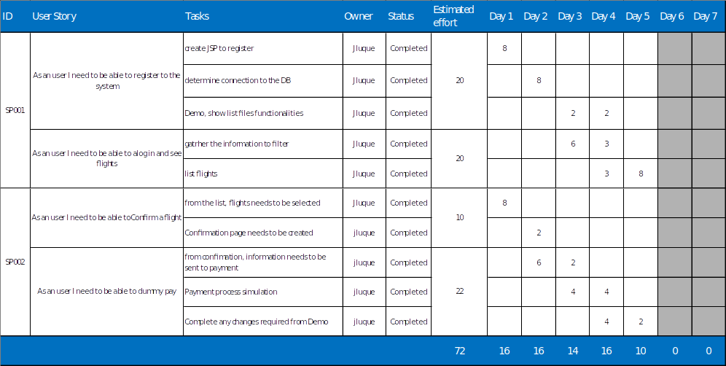

Algorithms
For this project, we have used Hibernate through spring-JPA, spring-boot, JSP and REST technology to create, modify and delete products, users and categories thero the admin module.

GitHub Tracking
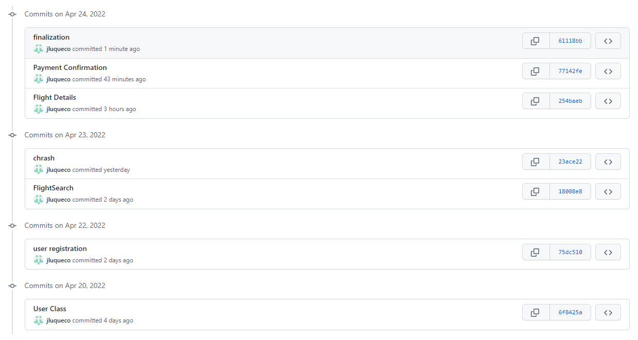

Conclusion
This project has been very important for the company and for the developer team. A lot of knowledge has been created and shared. This has been a successful project.

